Section A: Product Information Email

Good Evening,

This email concerns implementation of Nagios within the IT organization to solve the issue of server reporting. From my understanding this issue has been unresolved due to previous solutions costing more than the department wants to pay. Nagios is a free solution that can be developed from the ground up and can be developed in house by one of our software developers that already has previous experience with building a Nagios Infrastructure.

Setting up a basic test environment in Linux is easy, something we’ve already taken a few hours to do in order to illustrate how simple it is to install, setup, and configure. This solution solves two business issues, cost of purchase and cost of configuration. Deployment of our test instance can be easily changed because of documentation and learning material from Nagios which will allow us to quickly train IT personnel.

I sincerely hope we can get upper management onboard with this solution considering the advantages we have to gain. Looking forward to hearing back in the near future.

Sincerely,

xyz
B. Fact Sheet

Introduction
Linux operating systems are free to install leaving only the cost of hardware, which is still minimal in comparison to other solutions. Nagios is easy to install and configure following completion of several training videos lasting 1 hour in total. We’ve worked on this training to answer any questions that require a deep dive into the server configuration.

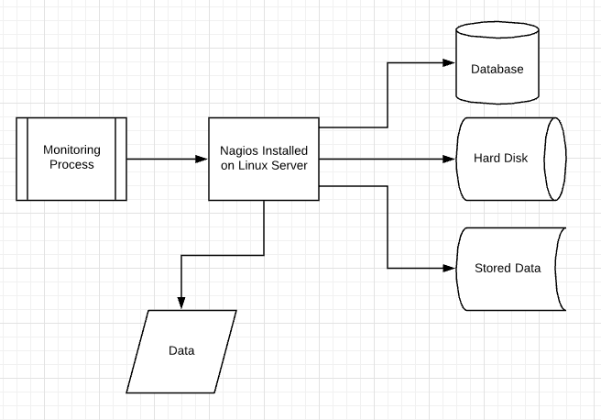
Product Description
Nagios is a Linux based monitoring tool that comes at a low cost as open source software.

Rationale for Implementation
The major concern with previous attempts has been cost. This solution is very low cost only leaving several purchases of hardware which equates to well below the overall cost of previously proposed solutions.

Summary of Implementation Phases
Phase 1 will be training anyone taking over the project so they can deploy the solution with us to ensure training sticks. Phase 2: We’ll spin up 6 VM’s on our existing lab data center in the office to support the on coming deployment. Phase 3: Deployment of configuration image of the Linux OS we’ve already put together. Phase 4: Testing and bug fixes. Phase 5: Project closure after handoff to owning IT team
C. Writing Process Analysis for Each Artifact
Writing Phase – Planning
The way in which I used this stage to create this document was to plan out the way to present certain material to a specific audience and the type of information or lack there of based on that audience. I also considered the reasons for such a document being required in the first place. Also some audiences have preference over the presence of tables or a fact sheet so including those was important.

Writing Phase – Multiple Drafting
Following research on my selected solution and writing an outline for the paper, writing up the first draft was the next step and revising the draft until the final version was up to paar with course requirements. I had to use LucidChart for creating the fact sheet and plan out what type of details would be important to me if I were the one looking at this document as the recipient of the work. I used this stage primarily for expanding on my plan/outline of items to present while not focusing on grammar and spelling. This helped get the information out and on paper in an organized fashion.

Writing Phase – Revising
This stage was continual while writing this document which resulted in new draft versions being created. At times I had to change the presented content and it’s cadence to ensure logical presentation. Other times I had to rework graphical aids to assist in making the solution click. I used mostly content and organization during writing this document to ensure proper completion along with grammar and spelling correction.
D. Audience Analysis for Each Artifact
- Subject Knowledge
  - Audience 1
    - It was important to remove acronyms or technical terms due to the possibility of executives not being technical. So keeping the document general as well as keeping the document very formal to meet the executives at the same level. Relaxed language should be avoided.
  - Audience 2
    - It was important to use technical language and being more specific with the solution instead of keeping it general. IT personnel would appreciate this difference and help their understanding of the solution.
- Position in the Organization
  - Audience 1
    - Typically people in higher positions within a company are at a broader perspective of the company. This means writing in a way that is general but get the point across quickly and precisely is import due to their schedules being busy. This may be the reason for task A being an Email and not a fact sheet.
  - Audience 2
    - IT personnel typically want to know the specifics of something that impacts their daily work if the call is made by upper management. Providing more detail in task B meets this requirement.
- Personal Attitudes
  - Audience 1
    - I decided to keep the email general but providing a few points for its support based on the assumption that the audience would have a positive attitude. I’d keep it much shorter and general if that was otherwise.
  - Audience 2
    - I made the same assumption for audience 2 as I did for the first and would apply the same principles I mentioned above if a good attitude over the topic was not present.
- Reading Style
  - Audience 1
    - I tried to keep task A general because I assumed the reading style of an executive to be quick to the point regarding content and reasons for supporting such a venture. Having technical terms and a lot of specifics would not adhere to this.
  - Audience 2

